Silver Fiddle Ranch Water

Water flows out of a spring into a 2500 gallon tank, and that tank overflows into the pond. There’s a pump in that tank that pumps water to the upper tanks above the house. The upper tanks gravity feed water to the house.

The pump shed has a pressure gauge on the pipes to the upper tank. Each upper tank has a stopcock that closes when the tank is full, this builds pressure in the lines and the pressure gauge will shut off the electricity to the lower pump. That keeps the tanks from overflowing. There’s also a timer on the electricity to the pump, this keeps the pump from cycling too often.

There are two upper tanks, and each one has an input and output valve. We leave the inputs open on both to make sure they are always full, but only open one output at a time, that way if there is a water problem (like someone leaves a hose on, or there’s a water line break), there’s still a full 2500 gallon tank.

The house water will go to through the water softener in the pump shed, but the ranch and water garden water will come directly from the tank. We left some hand-drawn plans that give the gist of it.
Ranch and Garden Water
Tank
Water Softener
Pump Shed
Spring
Tank
Pressure Gauge

Water Timer:

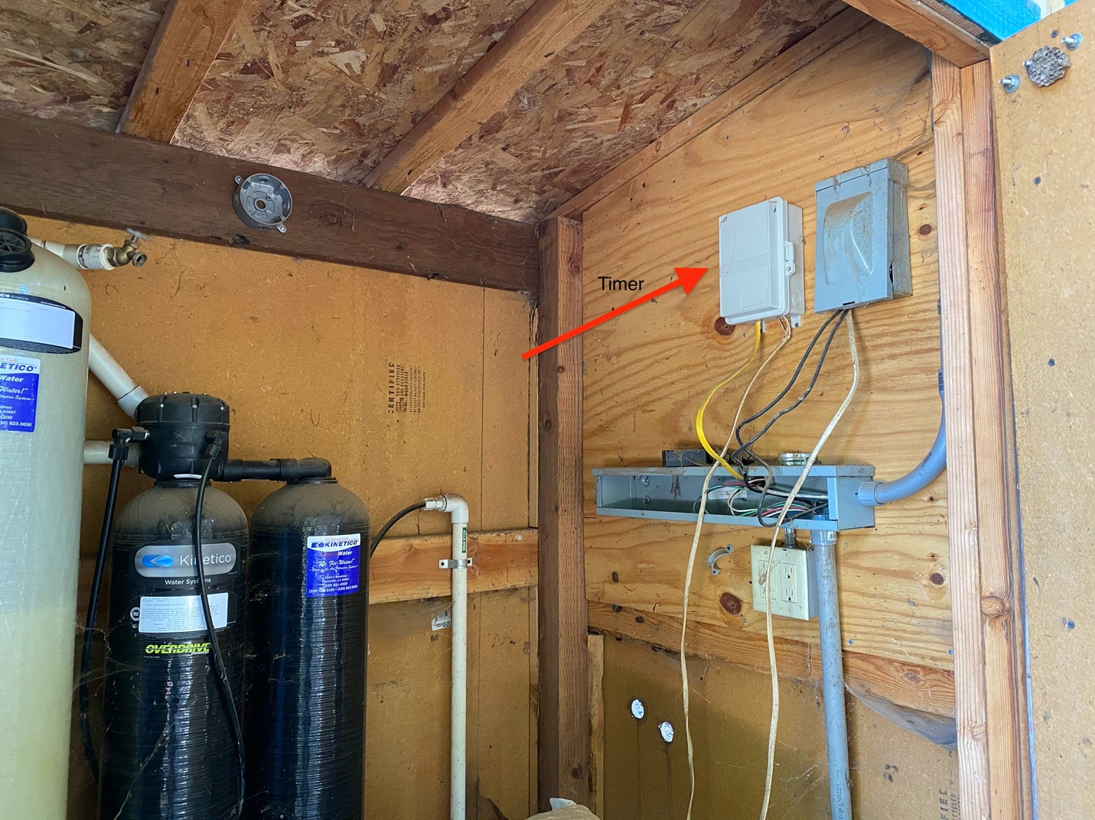

Winter Shutoff

The yard irrigation isn’t insulated and needs to be shutoff for the winter, usually Nov-March. There are two shutoffs, the first one is by the propane tank: The valve will shut off the water to the faucets by the pool and down to the lower horse pasture. I turn the water off, then open the faucets to let the water drain a bit.

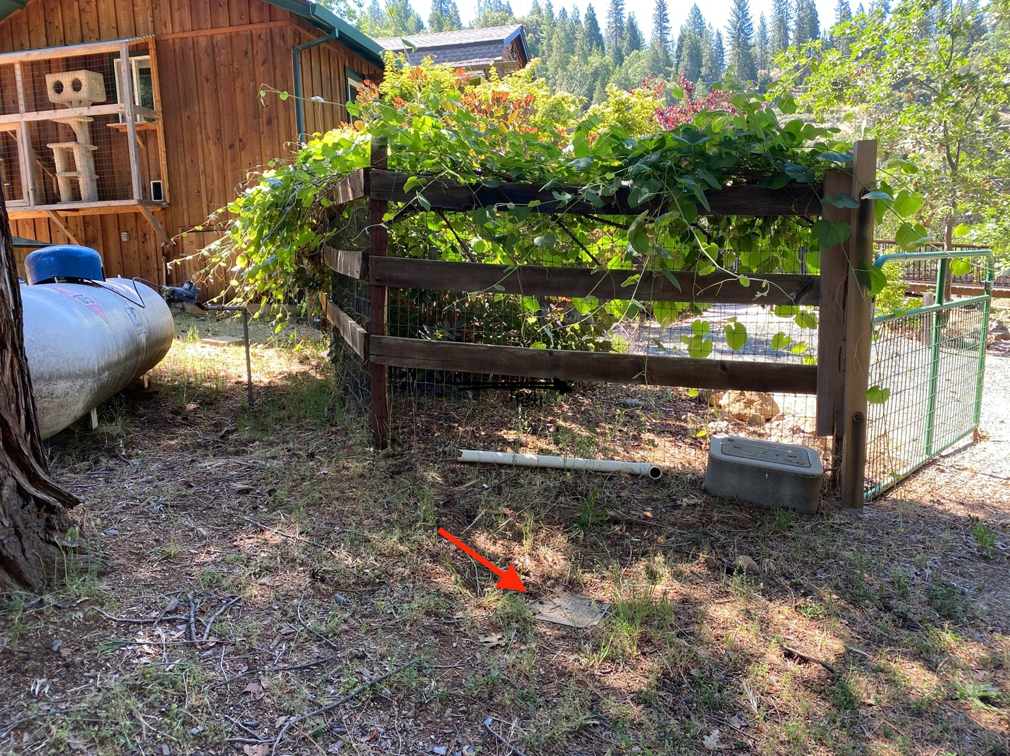

The second shutoff is by the house, it turns off the water for the front yard:

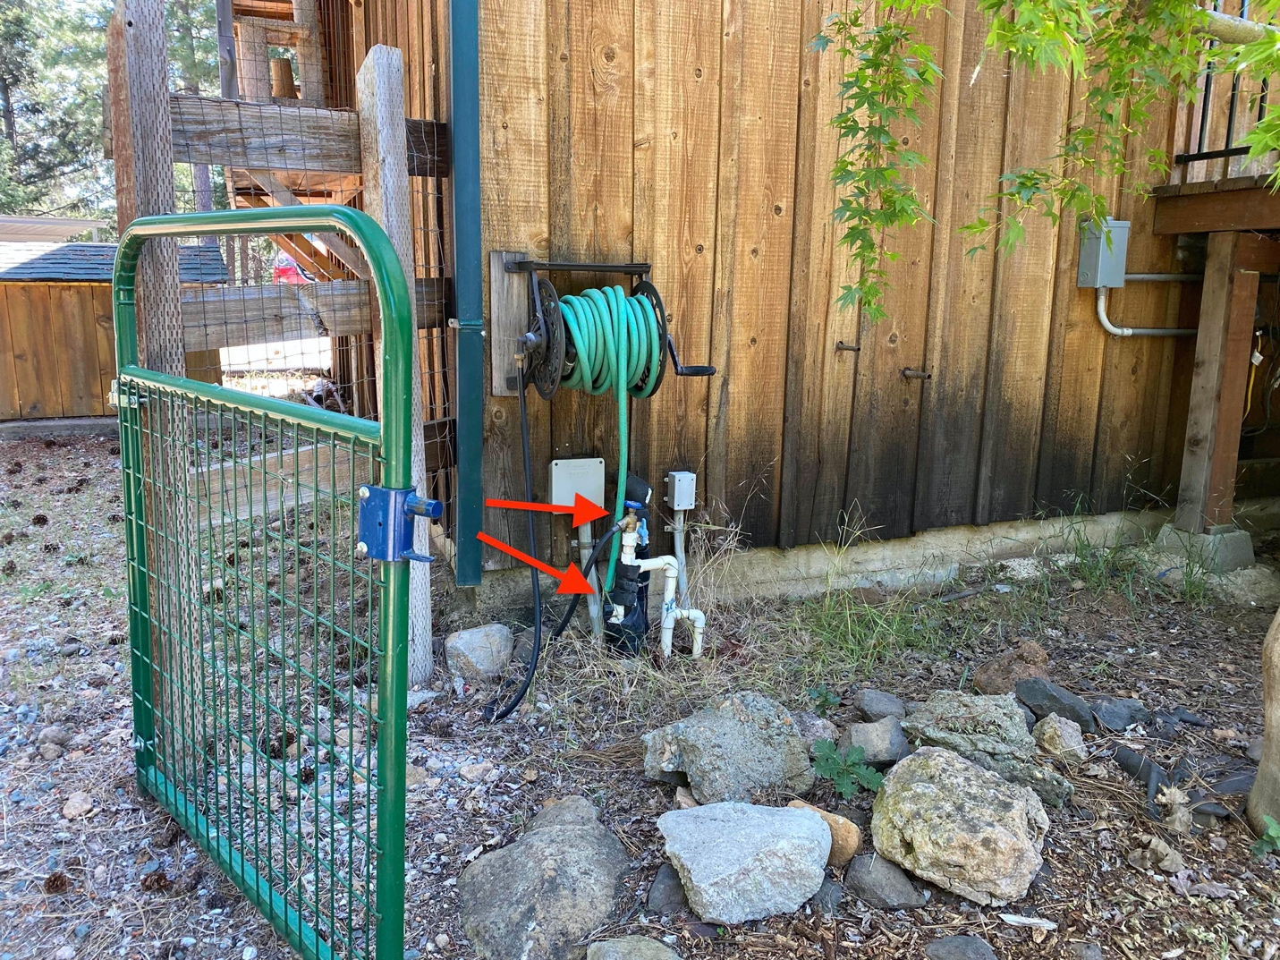

The rest of the water pipes should be insulated. The faucets need to be covered with an insulated faucet cover. We’ve had some occasional faucet pipe freezes in December if it stays below freezing for a few days, but never had a pipe break. There’s one “freezeless” red faucet with the valve below ground that should never freeze. Hoses, of course, will freeze over whenever it gets below freezing but will thaw back out.

